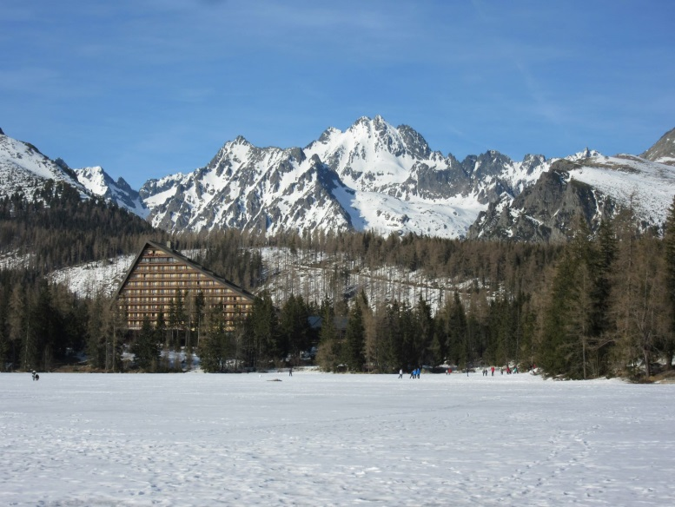 |  | 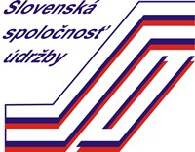  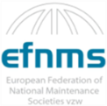  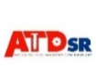  FIRST ANNOUNCEMENT  AND  CALL FOR PAPERS  TO  THE INTERNATIONAL CONFERENCE
Dear friends and colleagues,  After the forced break caused by the COVID-19 pandemic in 2020, we would like to announce the holding of the international conference National Forum on Maintenance 2021. Due to the continuing unfavourable situation, the conference is postponed from May to October 26-27, 2021.  We hope that despite difficult circumstances in all areas of life, the conference will continue to maintain its position as the top maintenance event in Slovakia, which brings together top managers and maintenance specialists, representatives of companies offering innovative products and services for maintenance, as well as experts from practice and academia..  The mission of the conference from its origin is to: “Provide state-of-art information of high professional value and create favourable conditions for exchange of experience among maintenance professionals from Slovakia and abroad“.  We invite you again to share your experience and to introduce progressive methods and solutions that you apply in challenging maintenance conditions, to introduce new products and technologies that lead to higher effectiveness, quality and safety in maintaining the value of physical assets.  SSU Board of Management |  | National Forum on Maintenance 2021  20th year  Vysoké Tatry, Štrbské Pleso, Hotel PATRIA  October 26 – 27, 2021  CONFERENCE TOPICS  - New trends in maintenance management  - Best practice in operation and maintenance  - Maintenance-Automotive  - Maintenance information systems  - Cyber-security and maintenance  - Predictive maintenance and diagnostics  - Innovative maintenance technologies  - Occupational health and safety  - Training and education in maintenance  - Infrastructure and facility maintenance
Professional Guarantors: | Conference Preparatory Committee:
- Hana Pačaiová  - Martin Pexa  - Peter Zvolenský | - Michal Abrahámfy  - Dušan Belko  - Gabriel Dravecký  - Katarína Grandová  - Juraj Grenčík  - Jan Hroch  - Vendelín Íro |  | - Stanislava Koleničová  - Krzysztof Olejnik  - Viera Peťková  - Miroslav Rakyta  - Marko Rentka  - Michal Žilka
Deadlines:
Abstract Submission | Notification on Acceptance |  | Submission of the Paper
May 31, 2021 | June 30, 2021 |  | August 31, 2021

Conference languages - Slovak, Czech, English – translating (according to number of foreign participants).

Conference fee: Participant, SSU member 160,- €
Participant, not SSU member 260,- €
Speaker, academia 70,- €
Speaker, company presentation 350,- €
Accommodation is paid by a participant; it is not included in conference fee.
Invitations with the Preliminary Programme will be sent by August 15, 2021.

Slovenská spoločnosť údržby, Koceľova 15, 815 94 Bratislava
International conference
NATIONAL FORUM ON MAINTENANCE 2021
October 26 – 27, 2021, Vysoké Tatry, Štrbské Pleso, Hotel Patria

SUBMISSION OF PAPER
Author (Title, Name, Surname): Position:
Organisation:
Address:
Tel.: E-mail:
Title of the paper:
Abstract:

Instructions for writing a paper will be sent to the author after its acceptance to the conference programme.
Conference Preparatory Committee has right to select papers into the conference programme with respect to content and topic of a paper. Presentation can be in the form of a lecture or a poster.
Please, send the title of the paper by e-mail to the address: grencik@ssu.sk Tel: ++421-(0)903 682 207

COMPANY PRESENTATION
Organisation:
Address:
Participant (name, surname):
Tel.: E-mail:
Tick the form of your company presentation:
Partner Exhibition Advertisement Commercial presentation
Conditions for partnership (different levels), exhibition, respectively advertisement in the conference proceedings will be sent on request.
Please, send the application for a company presentation to: iro@ssu.sk Tel.: ++421 (0)905 234 433

PRELIMINARY REGISTRATION AND HOTEL RESERVATION
Participant (name, surname): Position:
Organisation:
Address:
Tel. E-mail:
Note: Due to capacity of the Hotel Patria in Strbske Pleso, the number of rooms is limited and we suggest early booking through SSU
 | 25 / 26 Oct. 2021 | 26 / 27, Oct. 2021 | Other day - specify
Single | ☐ | ☐
Double (2 persons) | ☐ | ☐
Prices for rooms: single bed: 78,- € double bed: 88,- €
Lux single: 98,- € Lux double: 108,- € Lux extra bed: 36,- €
Lux app.: 141,- € Standard app.: 135,- €
Additional local fee is charged by hotel. Car parking, swimming pool, wellness, fitness, Wi-Fi are included in the price.
Accommodation is paid by a participant; it is not included in conference fee..
Send the PRELIMINARY REGISTRATION AND HOTEL RESERVATION by e-mail to iro@ssu.sk.
It is possible to order accommodation separately at Hotel TOLIAR
Prices for rooms: double: 65,- €, single: 46,- €.
Contact to the hotel reception: E-mail: kanc@tatry-toliar.sk, Tel.: 00421 52 4492 193
Accommodation at hotel Toliar is arranged individually (www.hoteltoliar.sk)

Consent to the processing of personal data
(According to Act no. 122/2013 Coll. on the protection of personal data and on amendments to certain acts)
I hereby grant my consent under § 11 of Act no. 122/2013 Z.z. on the protection of personal data and on amendments and supplements to certain laws with the processing of my personal data by the Slovak Maintenance Association (SSU), (Koceľova 1, 815 94 Bratislava) IČO: 37803310, listed in the return of this application for the NFU 2020 conference, as well as the publication of video and audio recordings from the NFU 2020 conference. The purpose of processing personal data is to clearly identify.

Given at: . Date: Signature:

